Assignment screeshoot

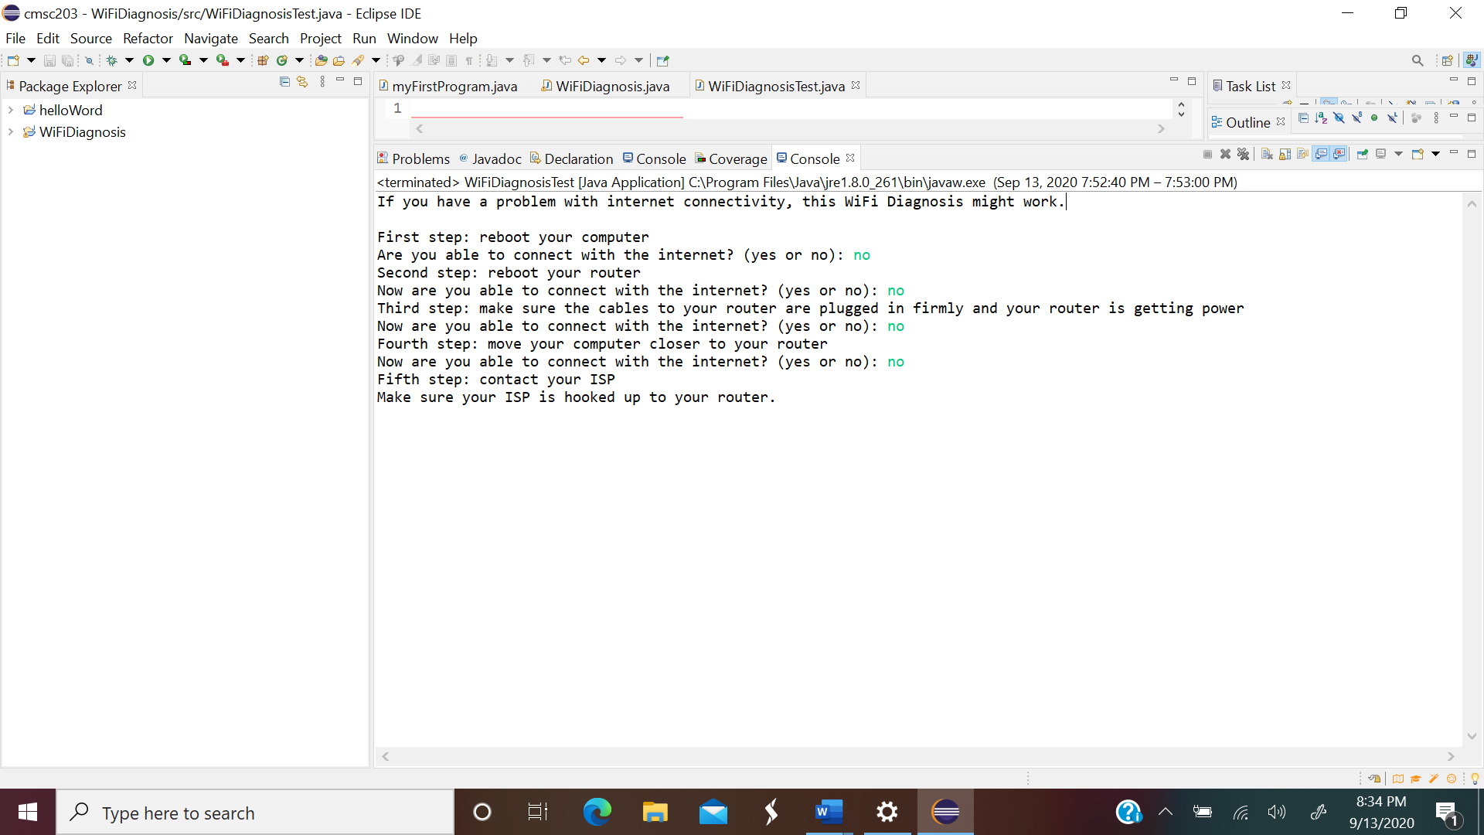

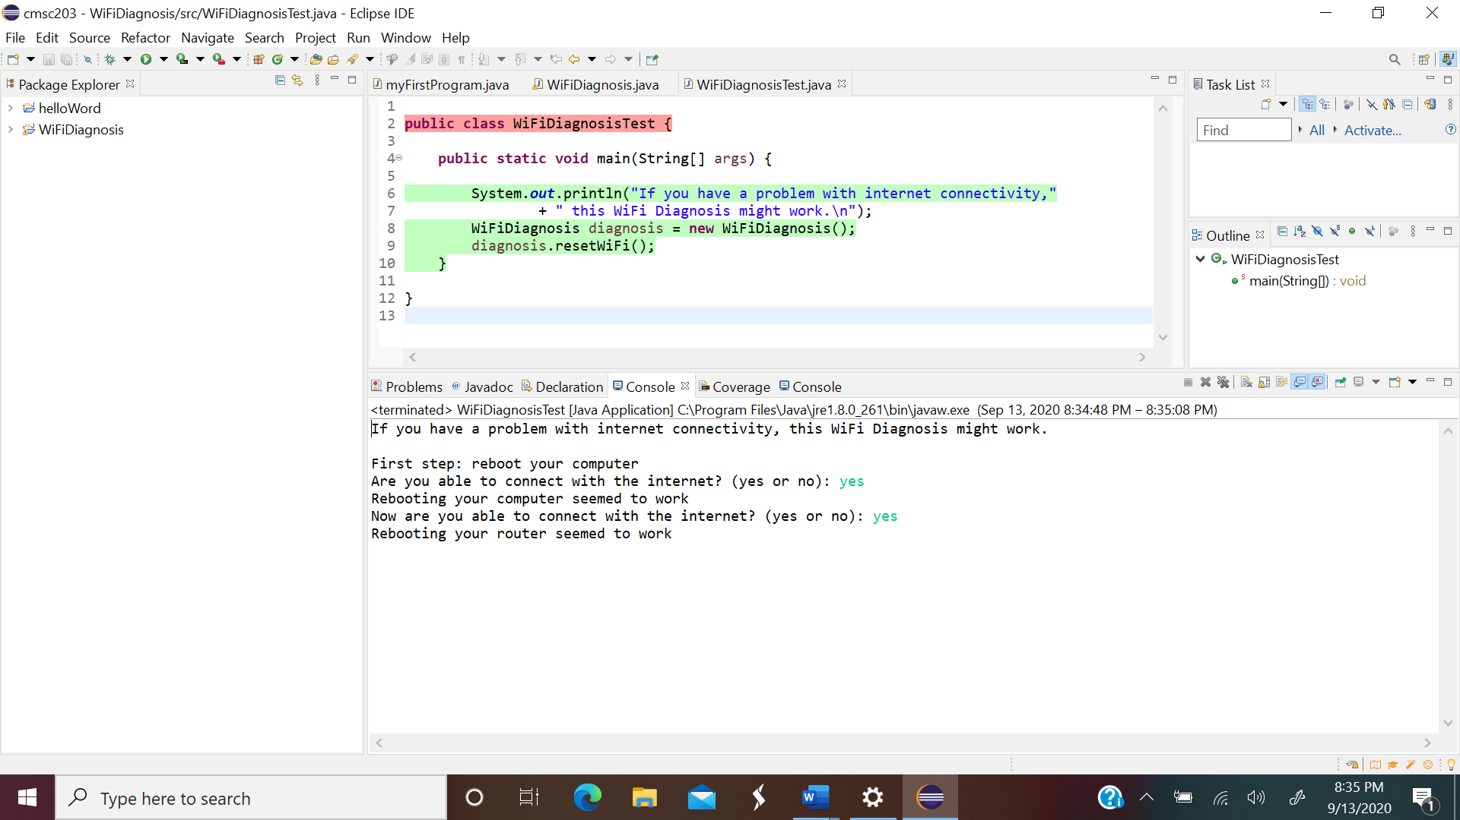

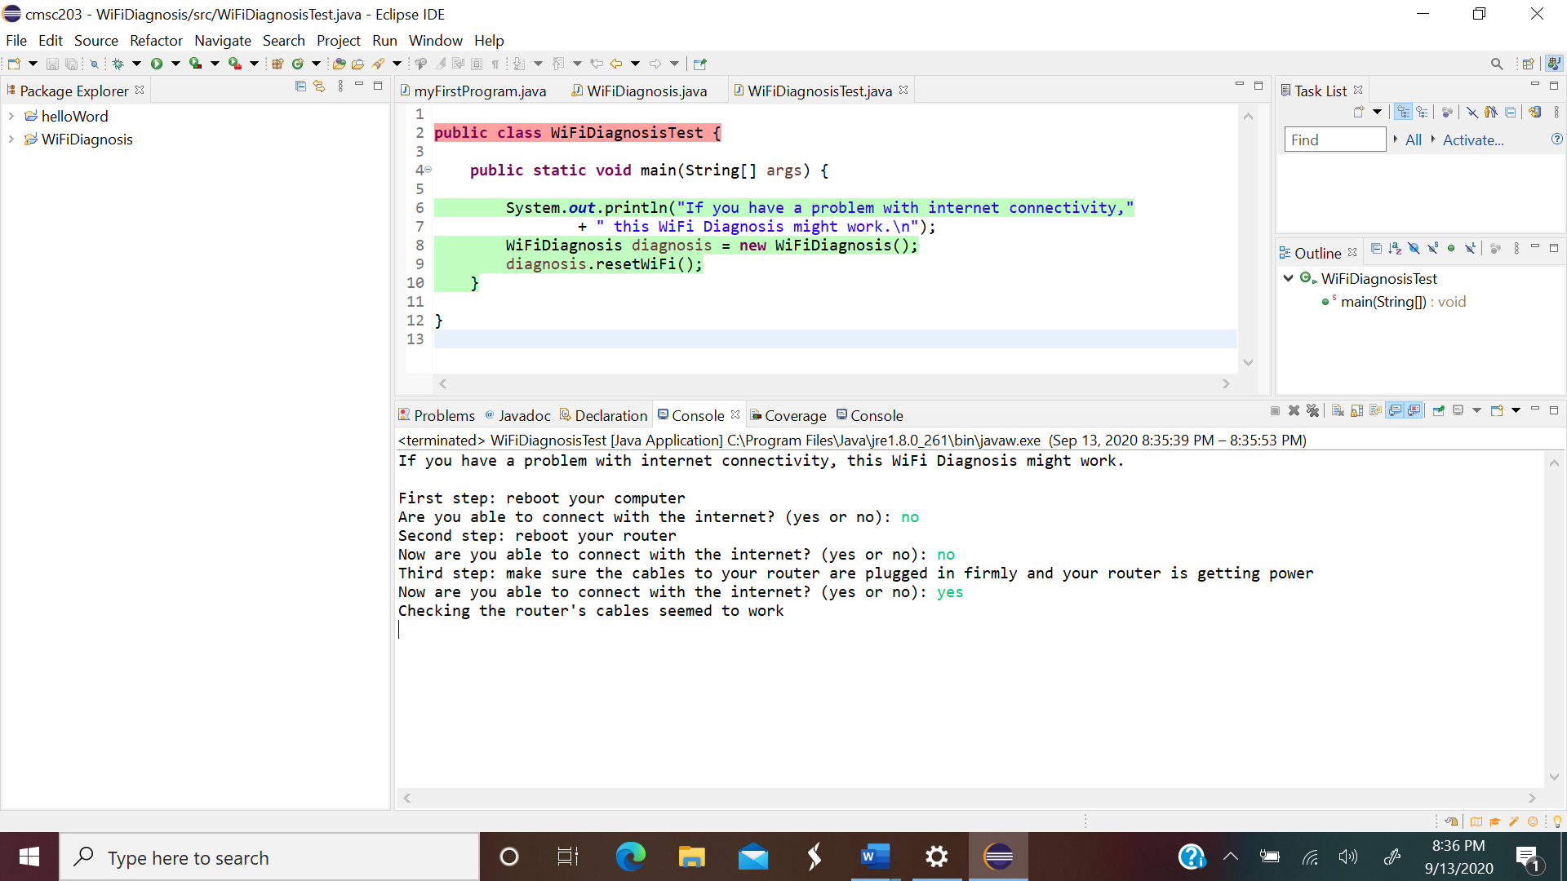

Lesson learn

In this program, I learn how to make decision. I learned how to use while loop, and if statement. Furthermore, I learned how to create and use the pseudocode.

Pseudo-code:

